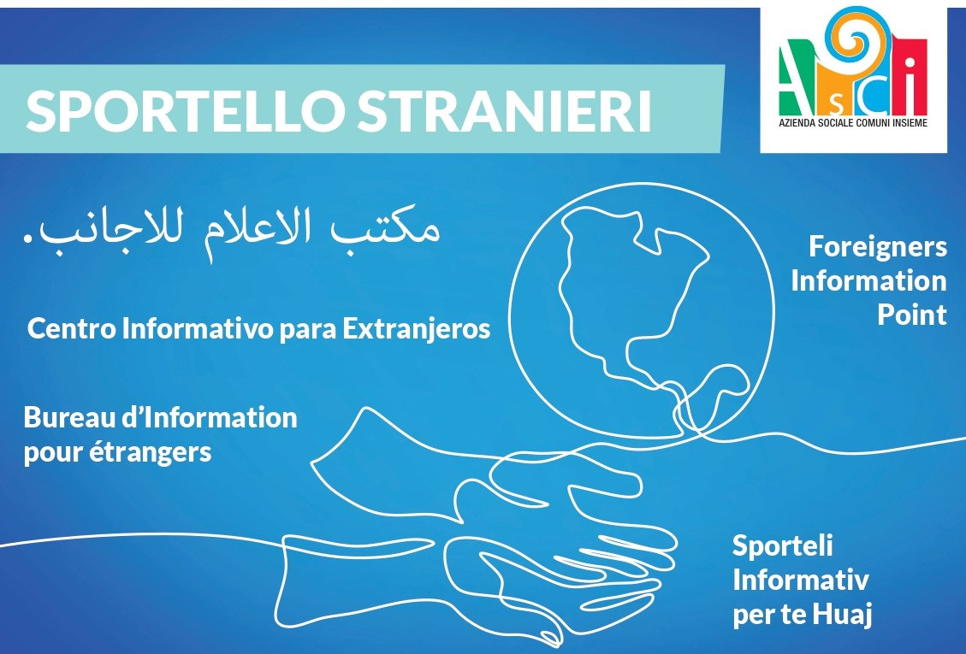
CHIUSO/CLOSED/FERMÉ /CERRADO/ЗАКРИТЕ/MBYLL/ KAPALI/بند/مغلق:

02/04/2024, 04/04/2024, 05/04/2024

